

Assessment Cover Page
Student Full Name
Valeria da Silva Dionisio
Student Number
2025627
Module Title
Algorithms and Constructs

Assessment Title
CA2 – Integrated -SDF -Algorithms

Lecturer/Supervisor
Taufique Ahmed

Assessment Due Date
23 may
Date of Submission
22 may 2026
Use of AI Tools
I acknowledge the use of ChatGpt for the purpose of to help check the grammar of my writing, as English is not my first language. I also used it to help organise my ideas and to clarify techniques from the module material when I was not fully understanding them.
Declaration
By submitting this assessment, I confirm that I have read the CCT policy on academic misconduct and understand the implications of submitting work that is not my own or does not appropriately reference material taken from a third party or other source.
I declare it to be my own work and that all material from third parties has been appropriately referenced.
I further confirm that this work has not previously been submitted for assessment by myself or someone else in CCT College Dublin or any other higher education institution.

Contents
1. Recursive Sorting Algorithm choice 1
2. Recursive Searching Algorithm choice 1
3. Evidence of program functionality 2
4. GitHub Repository Link: 5
5. References 5
6. Appendix 6

Recursive Sorting Algorithm choice

I chose recursive bubble sort because I wanted a recursive algorithm that was simple to implement, easy to follow, and suitable for the size of the employee list used in the system. Since the file does not contain a very large number of records, I did not think it was necessary to use a more advanced recursive algorithm such as Merge Sort or Quick Sort.
Another reason for this choice was readability. Although Merge Sort and Quick Sort are generally more efficient for very large datasets, they would have added unnecessary complexity to this system. My priority was to keep the code readable, organised, and easier to maintain
Bubble sort made it easier for me to organise the employee names alphabetically while still keeping the code clear and manageable. I also preferred this option because it worked well with the recursive requirement from the assignment brief without making the program unnecessarily complicated.

Recursive Searching Algorithm choice

I chose recursive binary search because the employee list is sorted before the search option is used. This made binary search a better fit than linear search, since it does not need to check every employee record one by one.
Another reason for this choice was efficiency. Because the algorithm reduces the search area during each step, it works faster and more effectively with an alphabetically sorted list. This matched the overall structure of the system, where the employee records are first read from the file, then sorted, and only afterwards searched.
Although linear search would have been easier to implement, it would not have taken advantage of the sorted employee list. Recursive binary search also allowed me to meet the assignment requirement for a recursive searching algorithm while keeping the code organised and consistent with the recursive sorting implementation.

302 – 500 words allowed

Evidence of program functionality
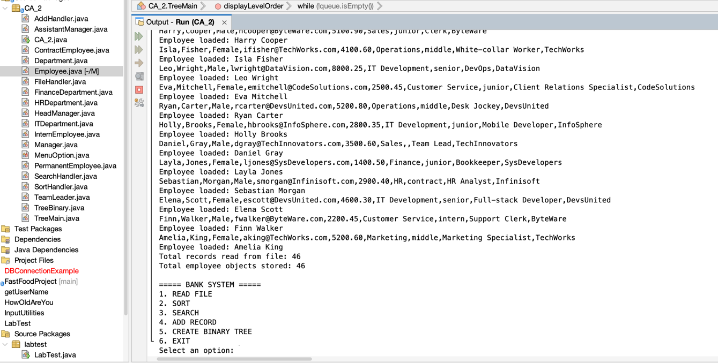
1

Figure 1 – Employee records successfully loaded from the file and stored in the ArrayList.
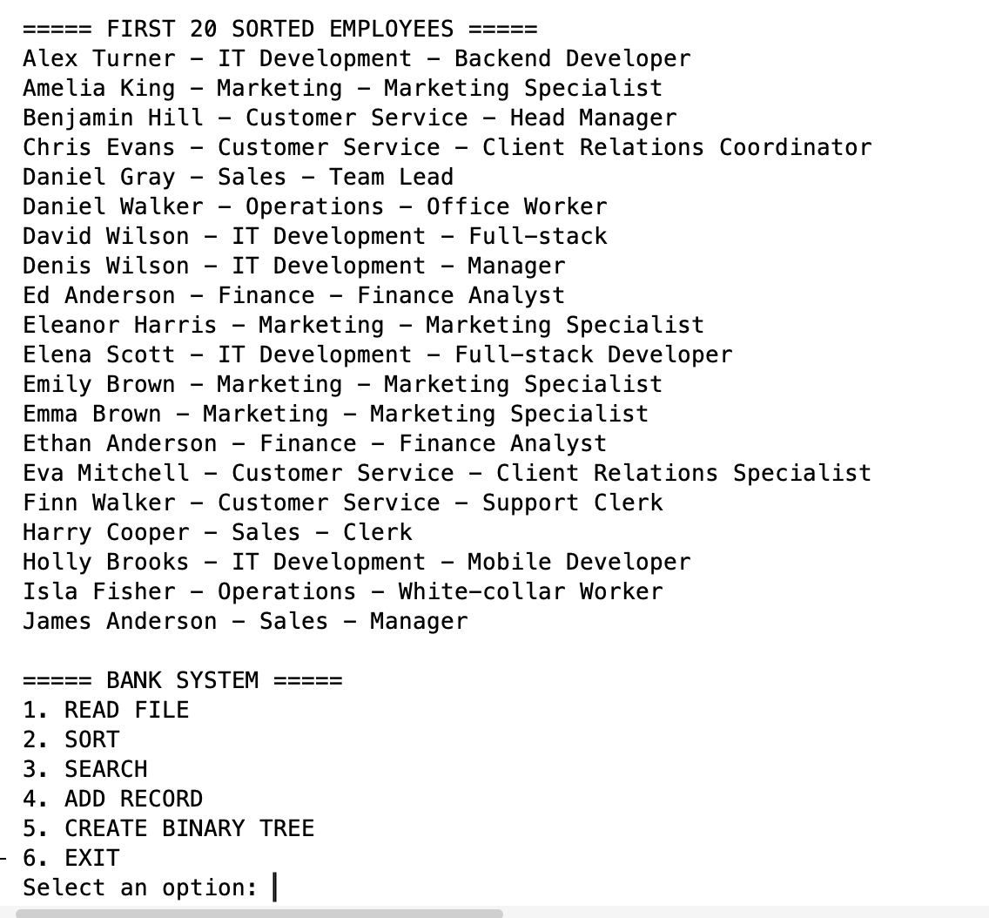
2

Figure 2 – Recursive bubble sort displaying the first 20 employee records in alphabetical order.
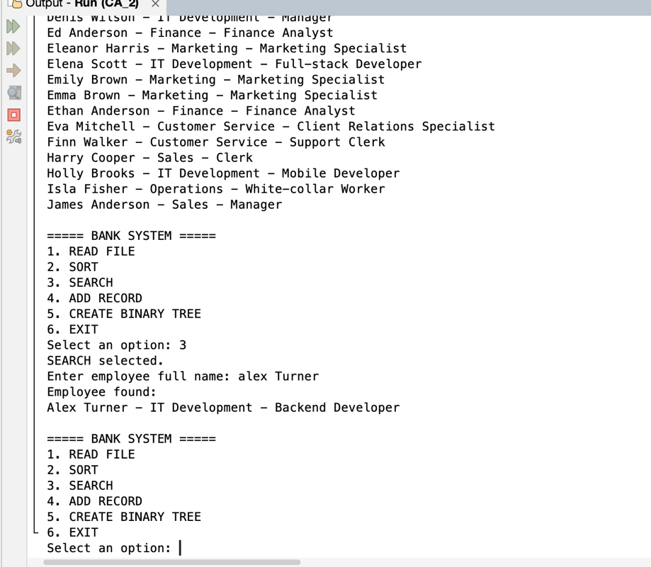
3

Figure 3 – Recursive binary search returning the selected employee information from the sorted list.
4
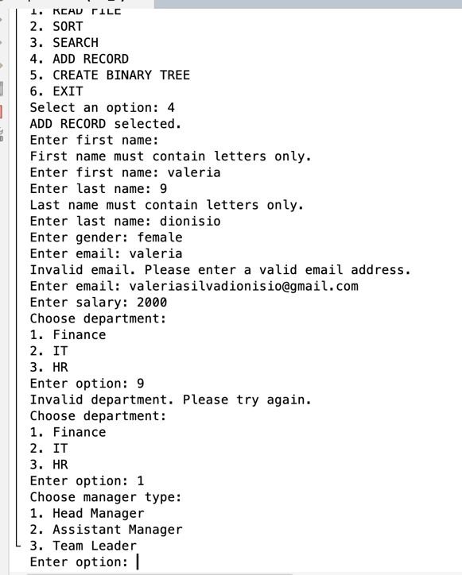
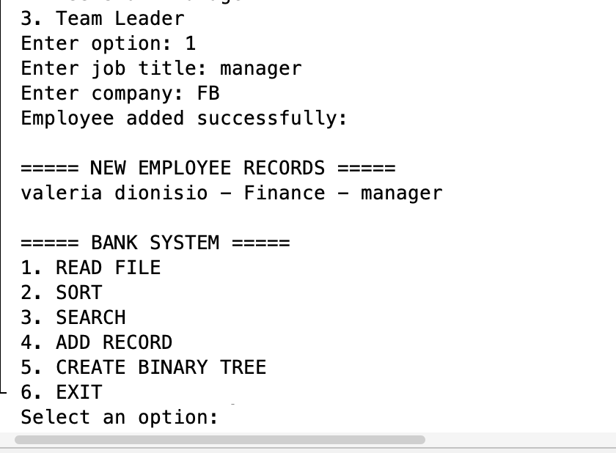

Figure 4 – Add Record option showing input validation and the newly added employee record.

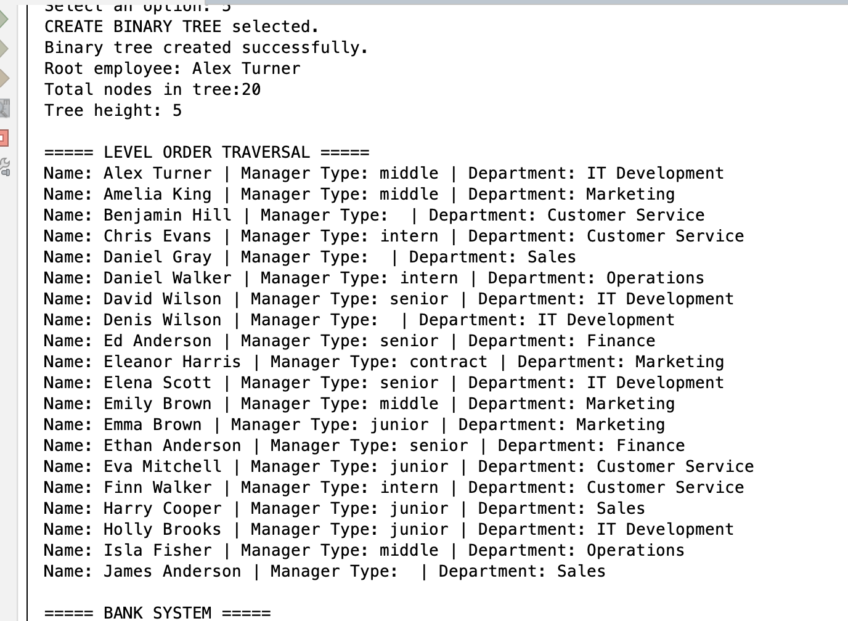
5

Figure 5 – Binary tree hierarchy showing level-order traversal, tree height and total node count.
6
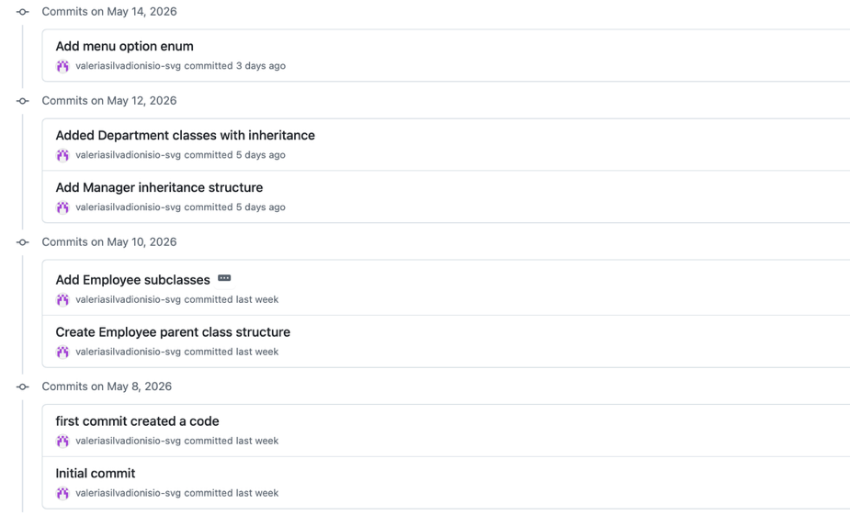
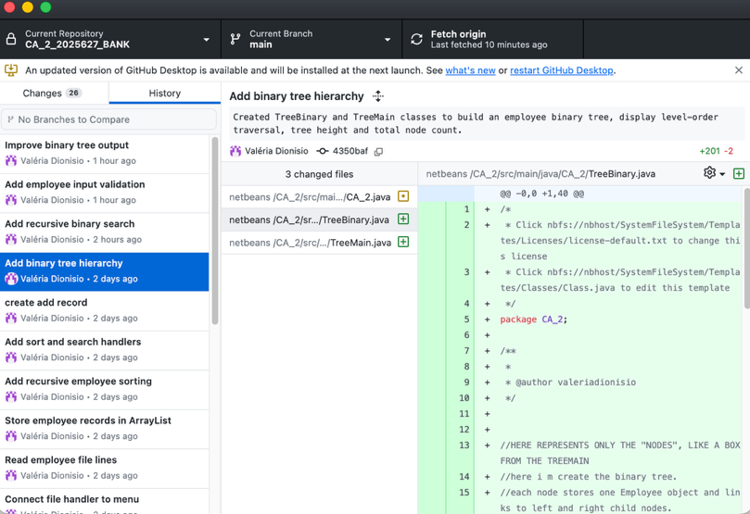

Figure 6 – GitHub commit history showing version control throughout the project development process, with a total of 19 commits created during implementation.

GitHub Repository Link:

https://github.com/valeriasilvadionisio-svg/CA_2_2025627_BANK.git

References

CCT College Dublin (2026) Bubble_Sort_Explanation.pdf Moodle lecture material.

CCT College Dublin (2026) EmployeeTree.pdf Moodle lecture material.

CCT College Dublin (2026) MergeSort_Full_Explanation_and_Trace.pdf Moodle lecture material.

CCT College Dublin (2026) Linear and Binary Search.pdf Moodle lecture material.

Oracle Java Documentation. Available at: https://docs.oracle.com/javase/

W3Schools Java Tutorial. Available at: https://www.w3schools.com/java/

GeeksforGeeks Bubble Sort Algorithm. Available at: https://www.geeksforgeeks.org/bubble-sort-algorithm/ (Accessed: 15 May 2026)

GeeksforGeeks Binary Search. Available at: https://www.geeksforgeeks.org/binary-search/ (Accessed: 17 May 2026)

GeeksforGeeks Binary Tree Data Structure. Available at: https://www.geeksforgeeks.org/binary-tree-data-structure/ (Accessed: 17 May 2026)

Stack Overflow Java Programming Discussions. Available at: https://stackoverflow.com/questions/tagged/java (Accessed: 08 May 2026)

Appendix

I mainly used ChatGPT to help clarify some programming concepts when I was struggling to fully understand parts of the module material, especially topics such as recursive bubble sort.
I also used it to help organise my ideas and improve the grammar of my writing, since English is not my first language. The practical implementation, coding decisions, testing, screenshots, and final work were completed and adapted by me.
I used the module materials, lecture PDFs and classroom examples provided by the lecturer throughout the development process. Some doubts related to the system functionality, recursive algorithms and project structure were also clarified during in-person class support sessions, helping me continue the implementation and improve the final solution.

